**(SSE-21/12/256/1)- DESIGN AND ANALYSIS OF POLARIZATION RECONFIGURABLE ANTENNA FOR REFLECTION COEFFICIENT AT 2.4GHz AND COMPARE WITH AND WITHOUT SLOT**

**PICO:**

**Problem:** Switchable slots are incorporated into patches on using diodes

**Intervention:** a simple low profile slot creation

**Comparison:** Reflection coefficient of with and without slot

**Outcome:** Frequency vs Reflection coefficient(with and without slot)

**INTRODUCTION:**

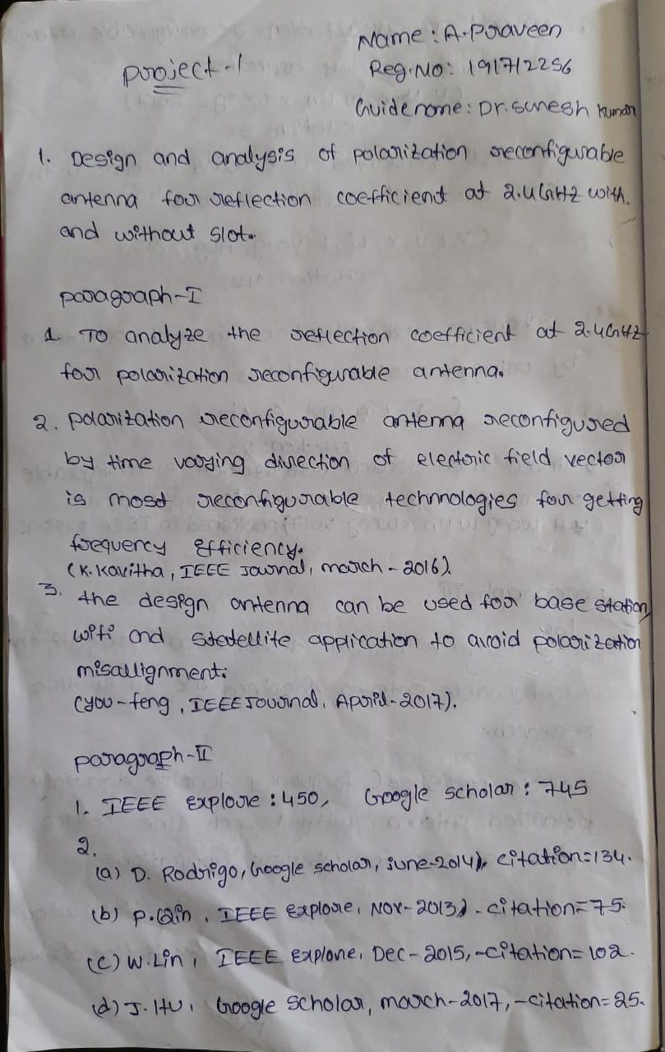



**MATERIALS AND METHODS**



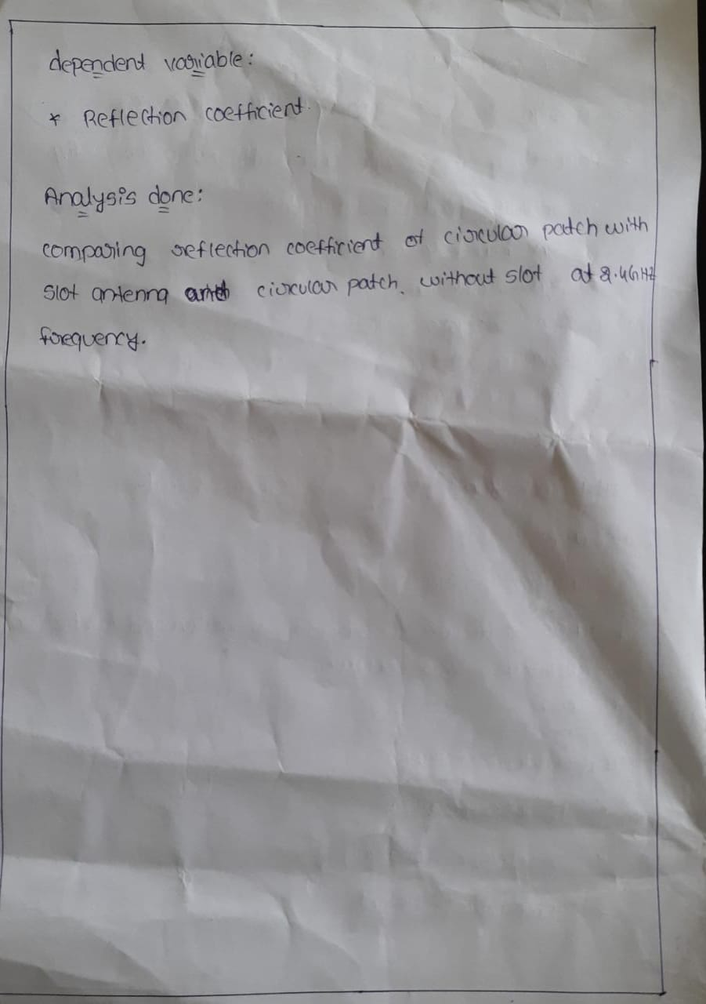

**DESIGN AND ANALYSIS OF POLARIZATION RECONFIGURABLE ANTENNA REFLECTION COEFFICIENT AT 2.4 GHz and COMPARE WITH and WITHOUT SLOT**

**Data Collection: with and without slot**

|  |  |  |  |  |  |  |
| --- | --- | --- | --- | --- | --- | --- |
| S.NO | GROUP1 | FREQUENCY | REFLECTION-COEFFICINT | GROUP2 | FREQUENCY | REFLECTION-COEFFICINT |
| 1 | 1 | 2.25 | -.8423 | 2 | 2.25 | -.6139 |
| 2 | 1 | 2.30 | -1.5602 | 2 | 2.30 | -1.0333 |
| 3 | 1 | 2.35 | -3.6561 | 2 | 2.35 | -2.0939 |
| 4 | 1 | 2.40 | -8.4376 | 2 | 2.40 | -5.3322 |
| 5 | 1 | 2.45 | -10.4445 | 2 | 2.45 | -11.5181 |
| 6 | 1 | 2.50 | -4.2479 | 2 | 2.50 | -4.6105 |
| 7 | 1 | 2.55 | -2.0437 | 2 | 2.55 | -2.0854 |
| 8 | 1 | 2.60 | -1.2294 | 2 | 2.60 | -1.2073 |
| 9 | 1 | 2.65 | -.8586 | 2 | 2.65 | -.8240 |
| 10 | 1 | 2.70 | -.6634 | 2 | 2.70 | -.6282 |
| 11 | 1 | 2.75 | -.5507 | 2 | 2.75 | -.5176 |
| 12 | 1 | 2.80 | -.4819 | 2 | 2.80 | -.4513 |
| 13 | 1 | 2.85 | -.4388 | 2 | 2.85 | -.4105 |
| 14 | 1 | 2.90 | -.4120 | 2 | 2.90 | -.3856 |
| 15 | 1 | 2.95 | -.3963 | 2 | 2.95 | -.3713 |
| 16 | 1 | 3.00 | -.3887 | 2 | 3.00 | -.3646 |

**TABLE AND GRAPH(SPSS):**

**Group Statistics:**

|  |  |  |  |  |  |
| --- | --- | --- | --- | --- | --- |
|  | group | N | Mean | Std. Deviation | Std. Error Mean |
| frequency | With slot | 16 | 2.6250 | .23805 | .05951 |
| withoutslot | 16 | 2.6250 | .23805 | .05951 |
| Reflection coefficient | withslot | 16 | -2.290757 | 3.0435335 | .7608834 |
| withoutslot | 16 | -2.027977 | 2.9475509 | .7368877 |

**Independent Samples Test:**

|  |  |  |  |  |  |
| --- | --- | --- | --- | --- | --- |
|  | | Levene's Test for Equality of Variances | | t-test for Equality of Means | |
| F | Sig. | t | df |
|
| frequency | Equal variances assumed | .000 | 1.000 | .000 | 30 |
| Equal variances not assumed |  |  | .000 | 30.000 |
| Reflection coefficient | Equal variances assumed | .128 | .723 | -.248 | 30 |
| Equal variances not assumed |  |  | -.248 | 29.969 |

Comparison of reflection coefficient of with and without slot by varying the frequency ranging from 1GHz to 3GHz.there is statistically significant difference in reflection coefficient of with and without slot. The reflection coefficient of without slot is higher when compare to with slot.

**BAR CHART COMPARITIVE MEANS:**

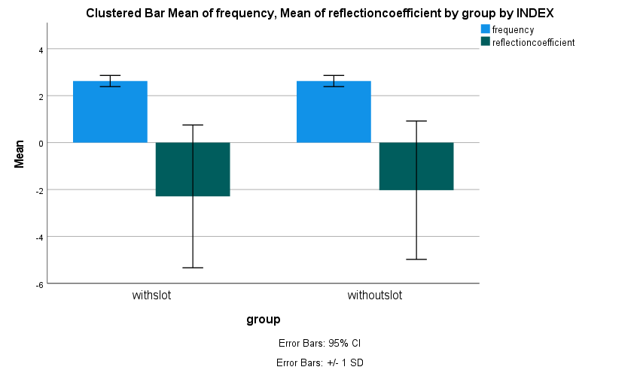

Fig. Bar chart comparing the mean reflection coefficient of with and without slot by varying the frequency. There is no significance difference between the two groups p>1.00(Independent sample t test).

**Results and Discussion:**

**WITHOUTSLOT REFLECTION COEFFICIENT:**

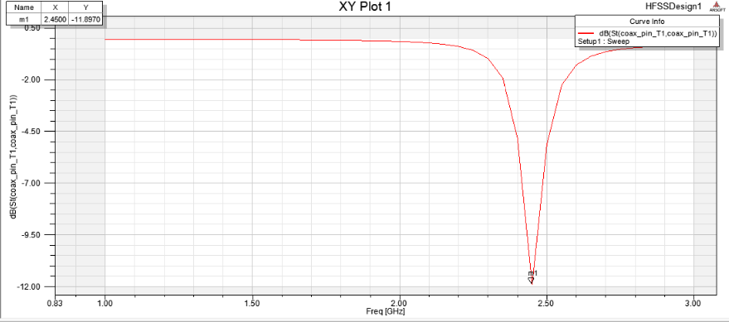

Frequency at 2.45GHz and Reflection coefficient without slot = -11.8970dB

**WITHSLOT REFLECTION COEFFICINT:**

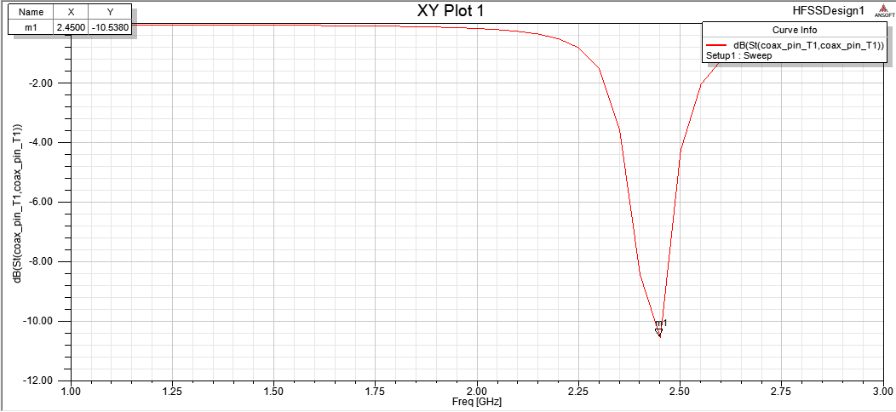

Frequency at 2.45GHz and Reflection coefficient with slot **= -10.5380dB**

**DISCUSSION HINTS**



